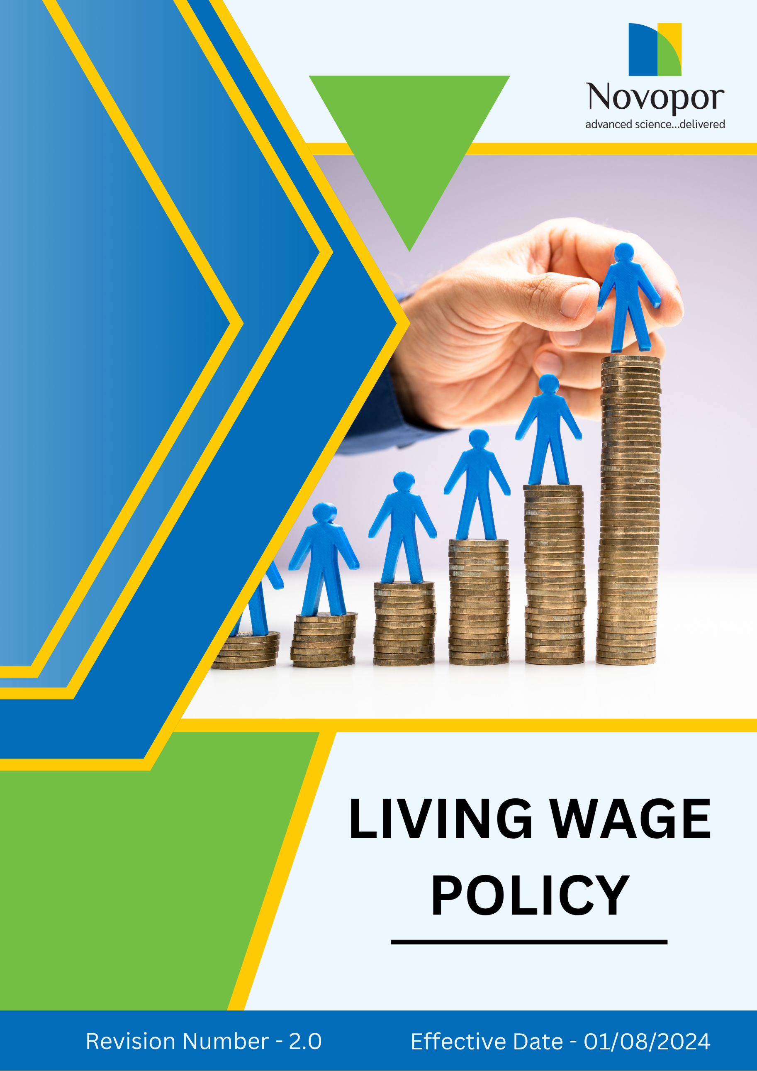

Table of Contents

➢ Introduction: 3
➢ Scope: 3
➢ Living Wages Commitment: 4
➢ Quantitative Targets: 4
➢ Action Framework: 5
➢ Roles and Responsibilities: 5
➢ Monitoring and Reporting: 6
➢ Communication and Transparency: 6
➢ Review: 7
➢ Employee Acknowledgement-Novopor Living Wages Policy 8

Introduction:
At Novopor, we believe that fair wages are fundamental to a dignified and sustainable livelihood. Our Living Wage Policy ensures that all employees receive compensation that not only meets their basic needs but also supports their overall well-being. By aligning with international labor standards, we strive to create a work environment where employees feel valued and financially secure. This policy reinforces our commitment to ethical business practices, employee welfare, and the economic growth of the communities in which we operate.

Scope:
This Living Wages Policy applies to all employees, contract workers of Novopor, including full-time, part-time, and temporary workers, across all our operations sites. It is applicable to all site locations mentioned below. It extends to suppliers and partners, ensuring that all parties engaged with Novopor living wage principles.
Site Name | Address | Primary Function
Andhra Pradesh | Plot No: 2A,2B & 2C, APSEZ, Moturupalem Village, Rambilli Mandal, Achyutapuram, Visakhapatnam District - 531011, Andhra Pradesh, India | Manufacturing Site
Andhra Pradesh | Plot no: 64, JNPC, Pharma City, Thanam Village, Visakhapatnam District, Parwada Mandal - 531019, Andhra Pradesh, India | Manufacturing Site
Telangana | K.K.R.Square, Flat No.402 & 403, Plot No.5,6,15 & 16, Kavuri Hills, Road No.36, Jubliee Hills, Hyderabad - 500033, Telangana, India. | Corporate Office
Telangana | Lab No.9, 1st Floor, Phase-1, IKP Knowledge Park, Sy. No. 234/2, 235/3 and 235/2, Turkapally Village, Shamirpet Mandal, Medchal-Malkajgiri District, Hyderabad - 500101, Telangana, India | Innovation Centre
Mumbai | Unit No.SO-4, 2nd Floor, Building No.14, Solitaire Corporate Park, Guru Hargovindji Road, Chakala, Andheri (East), MUMBAI-400093, India | Corporate Office

Living Wages Commitment:
At Novopor, we are dedicated to ensuring that all employees receive a fair and sustainable wage that enables them to meet their basic needs and maintain a decent standard of living. We recognize that fair compensation is essential for fostering a motivated, productive, and engaged workforce. By aligning with global labor standards and ethical business practices, we strive to create an environment where every employee feels valued and financially secure. Our Commitment is reflected in the following key areas:
- Wages Above Legal Minimum: At Novopor, we are dedicated to ensuring that every employee receives a living wage that allows them to meet their basic needs and maintain a decent standard of living. This commitment involves conducting wage assessments, adjusting salaries where necessary, and collaborating with stakeholders to uphold fair compensation.
- Continuous Wage Assessment: At Novopor, we recognize that maintaining a living wage is an ongoing responsibility, not just a one-time goal. We are committed to continuously reviewing and adjusting wages to reflect changes in economic conditions, inflation, and cost of living. Through regular wage assessments, transparent policies, and compliance with global labor standards, we ensure that our employees receive fair and sustainable compensation.
- Equal Pay for Equal Work: We are committed to fair and equitable compensation, ensuring that all employees receive equal pay for equal work, regardless of gender, age, ethnicity, or any other factor. We believe that compensation should be based on skills, experience, and job responsibilities, fostering a workplace built on fairness and transparency.

Quantitative Targets:
Sets FY 2022-23 as the Baseline for tracking our sustainability progress.

1. Wages Above Legal Minimum
- Ensure that 100% of employees receive a wage that is at least 15% higher than the legal minimum wage by FY 2028-29.
- Conduct annual wage reviews to adjust salaries based on inflation and cost-of-living changes by FY 2028-29.
- Extend living wage commitments to 100% of direct suppliers by FY 2028-29, ensuring fair pay across the supply chain.

2. Continuous Wage Assessment
- Perform wage assessments annually to ensure all salaries align with living wage benchmarks by FY 2028-29.
- By FY 2028-29, establish a wage transparency report, published annually, to track progress and maintain accountability.
- Ensure that 100% of employees have access to clear information about their pay structure and living wage policies by FY 2028-29.

3. Equal Pay for Equal Work
- Achieve zero gender pay gap across all job levels by FY 2028-29.
- Ensure that 100% of salary adjustments are based on skills, experience, and performance rather than gender or other biases by FY 2028-29.
- Conduct annual gender pay audits by FY 2028-29 to identify and address any disparities.

Action Framework:
- Annual Wage Reviews: Conduct annual wage reviews to ensure that employee compensation remains competitive, fair, and aligned with living wage benchmarks. This process includes analysing market trends, inflation rates, and cost-of-living adjustments to determine necessary salary revisions.
- Pay Audits: Pay Audits assess salary data across gender, role, experience, and location to identify and rectify any disparities. Any wage gaps discovered through these audits are addressed with corrective action plans, ensuring that all employees receive compensation based solely on their skills, experience, and job responsibilities.
- Employee Feedback: We conduct anonymous wage satisfaction surveys at least once a year, allowing employees to voice their concerns and expectations regarding compensation. Additionally, we maintain open communication channels, including HR consultations and dedicated grievance mechanisms, where employees can raise concerns about wage fairness.

Roles and Responsibilities:
Stakeholder | Roles & Responsibilities
Human Resources Department | - Ensure all employees receive at least a living wage as per company policy and market benchmarks.  - Conduct regular wage assessments and adjust salaries to align with cost-of-living changes.  - Develop and implement policies that promote fair compensation and pay equity.
Compliance & Legal Team | - Ensure compliance with labor laws, wage regulations, and ethical wage standards.  - Conduct audits to verify wage transparency and fairness.  - Address employee concerns regarding wage disparities and resolve grievances effectively.
Suppliers | - Commit to paying fair wages to workers in alignment with Noopur’s living wage standards.  - Provide wage data transparency and undergo periodic compliance checks.  - Implement fair wage policies across supply chains.
Managers & Supervisors | - Ensure team members receive fair compensation based on role, experience, and industry standards.  - Communicate wage policies transparently to employees.  - Provide feedback to HR on wage concerns and market competitiveness.
Employees | - Stay informed about their wage rights and company policies.  - Report any discrepancies or concerns regarding unfair wages.  - Participate in wage assessments and feedback programs to help improve compensation structures.

Monitoring and Reporting:
To uphold the effectiveness of Novopor’s Living Wage Policy, a structured monitoring and reporting framework is essential. This ensures transparency, accountability, and continuous improvement in fair compensation practices, employee well-being, and compliance with wage standards, fostering a more equitable and sustainable work environment.
- Annual Reporting: Publish an annual report on living wage compliance, outlining progress, challenges, and improvements in wage standards.
- Employee Feedback & Surveys: Regular employee surveys and feedback mechanisms are conducted to assess wage adequacy, financial well-being, and workplace satisfaction.
- Supplier Audits: Periodic audits of suppliers ensure adherence to Novopor’s living wage standards, promoting fair compensation across the supply chain.

Communication and Transparency:
- The Policy is publicly available on Novopor’s website and shared through various stakeholder communication channels.
- Employees are kept informed of updates and expected to integrate these practices into their work.

Review:
The implementation and review of Novopor’s Living Wage Policy is managed by the Human Resources Manager. This policy is reviewed annually to ensure its effectiveness, alignment with regulatory standards, industry best practices, and organizational commitments. Any updates or modifications are communicated to all stakeholders, reflecting operational or legal changes and addressing emerging challenges in fair wage practices.

Version | Date | Description of Changes | Approved By
1.0 | 01-08-2024 | Initial release | Management
2.0 | 01-01-2026 | Periodic review completed – no changes required. | Management

Approved By:

Designation:

Last Review Date: 01/01/2026 Next Review Date: 01/01/2027

Employee Acknowledgement-Novopor Living Wages Policy

I acknowledge that I have received, read, and understood the Novopor Living Wages Policy. I recognize the company’s commitment to fair compensation, employee well-being, and ethical business practices, including integrity, transparency, and compliance with wage standards across all operations. I understand my role in supporting this policy, which includes adhering to all applicable labor laws and ethical standards, ensuring fair wages, and fostering a workplace culture of respect and accountability.
I agree to uphold equitable compensation practices, report any concerns related to wage fairness or non-compliance, and actively contribute to Novopor’s initiatives for continuous improvement in employee welfare. Furthermore, I will raise any ethical concerns related to unfair wages, labor rights violations, or other wage-related issues and provide suggestions to strengthen Novopor’s commitment to a responsible and transparent work environment.
By signing below, I confirm my commitment to upholding the Novopor Living Wage Policy.

Employee Name:

Employee Signature:

Date:

